Exploratory Data Analysis (EDA) Insights
1. Summary Statistics
The initial analysis of 10,692 records revealed significant variance across key metrics:

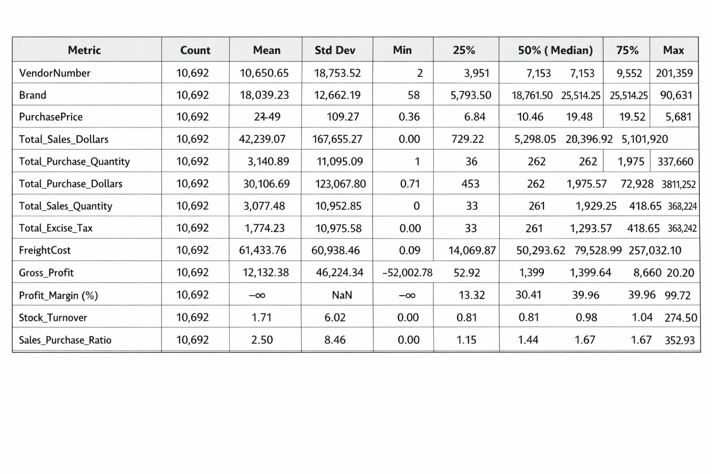

Extreme Revenue Concentration
- Insight: Median sales are $5,298, yet the maximum is $5.1M, indicating a massive gap between top and average performers.
- Impact: The business is heavily dependent on a few "blockbuster" brands or vendors, creating a high risk of failure if a top supply chain partner is disrupted.
Critical Margin Erosion
- Insight: Gross Profit shows losses as deep as -$52,002, and Profit Margin contains "-inf" values.
- Impact: Negative infinity margins suggest data errors or products being sold with zero revenue despite high costs, representing an immediate drain on capital.
Inventory Inefficiency ("Dead Stock")
- Insight: The 25th percentile for Stock Turnover is only 0.80, and some products have zero sales.
- Impact: At least 25% of inventory is stagnant, tying up cash flow in products that are not generating returns.
Logistics Crisis
- Insight: Average Freight Cost ($61,433) is more than five times the average Gross Profit ($12,132).
- Impact: Shipping expenses are currently unsustainable and are the primary factor preventing the conversion of high sales volume into net profit.
High-Yield Opportunities
- Insight: The maximum Sales-to-Purchase Ratio is 352, vastly exceeding the median of 1.43.
- Impact: Identifying and scaling the specific opportunistic products responsible for these extreme ratios offers the fastest path to increasing business liquidity.

2. Data Filtering & Reliability
To ensure the integrity of the final insights, inconsistent data points were removed:
- Loss-Leading Transactions: Removed records where Gross Profit ≤ 0 or Profit Margin ≤ 0.
- Unsold Inventory: Removed records where Total Sales Quantity = 0.

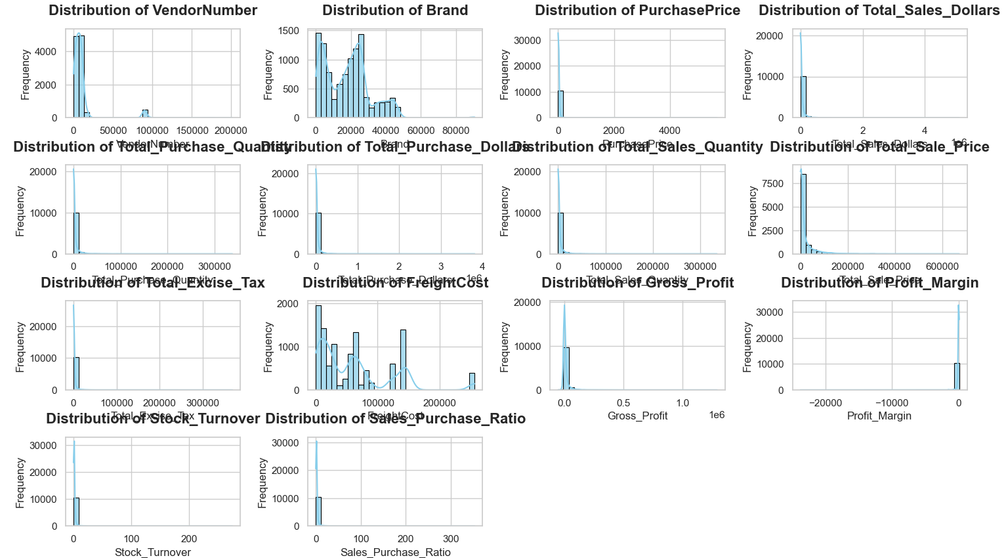

Pricing Variations: Purchase prices range from $0.36 to $5,681.81, while actual selling prices reach up to $7,499.99, indicating a broad mix of economy and premium offerings.
Financial Health: Gross profit shows a minimum of -$52,002.78, revealing potential losses due to high costs or aggressive discounting.
Inventory Velocity: Stock turnover ranges from 0 to 274.5, showing a sharp divide between rapid-sellers and stagnant inventory.

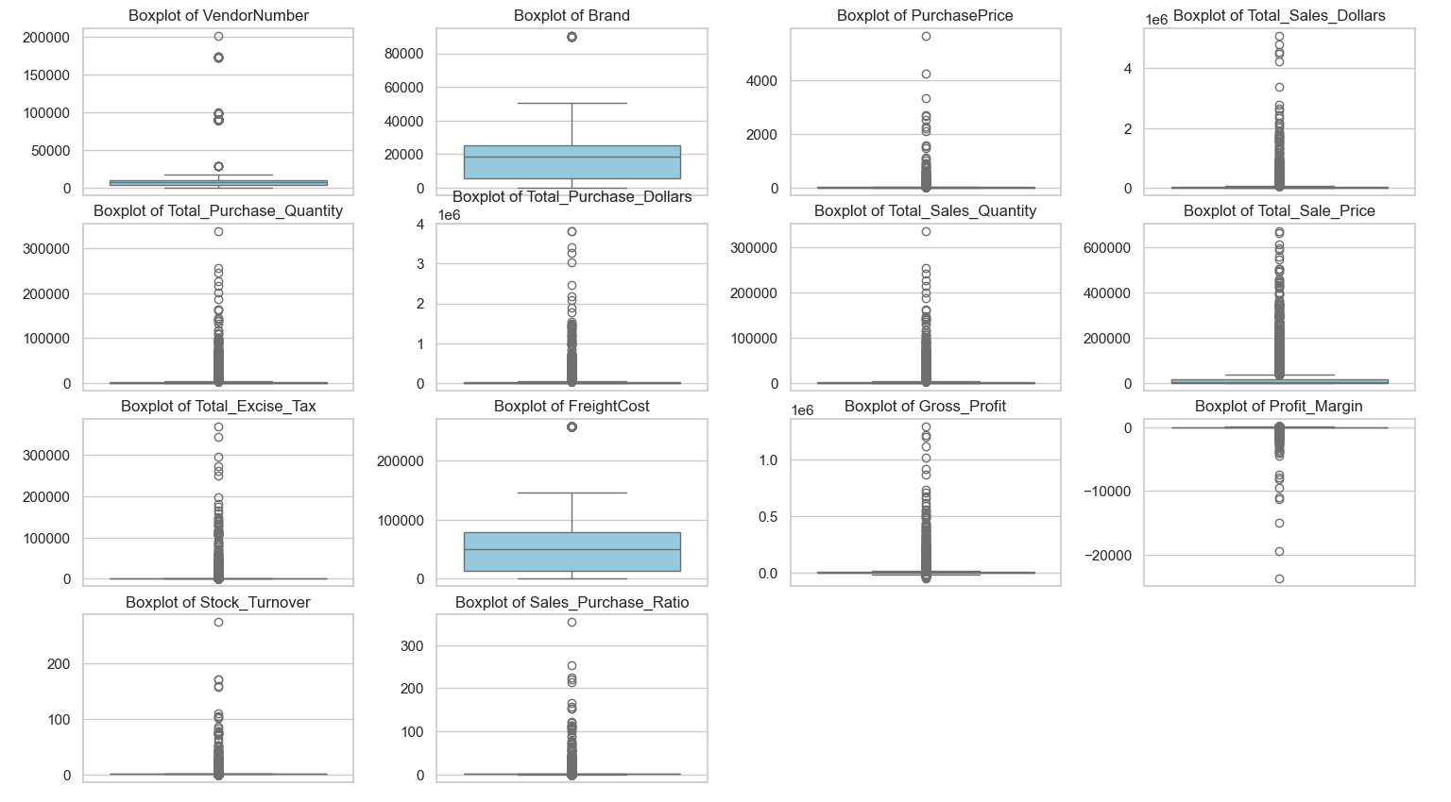
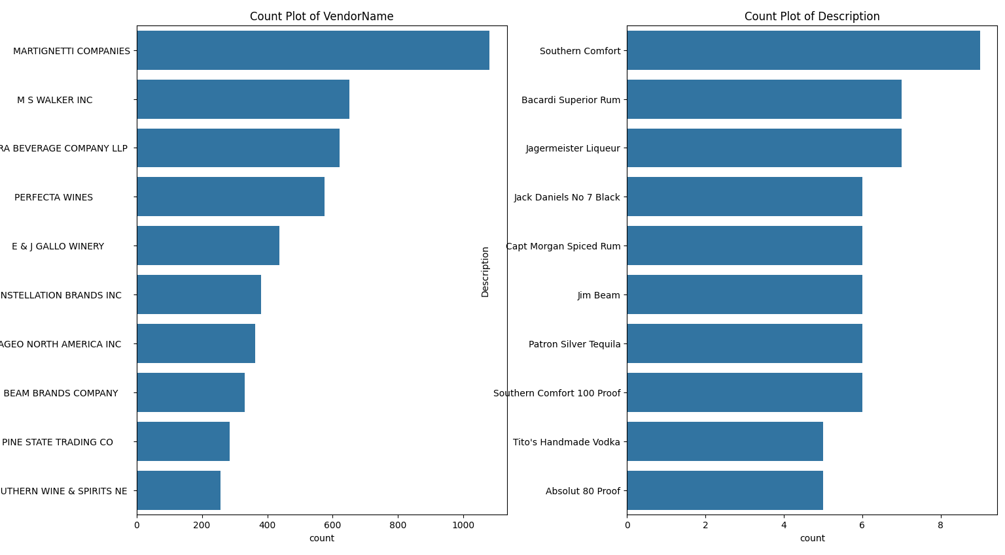

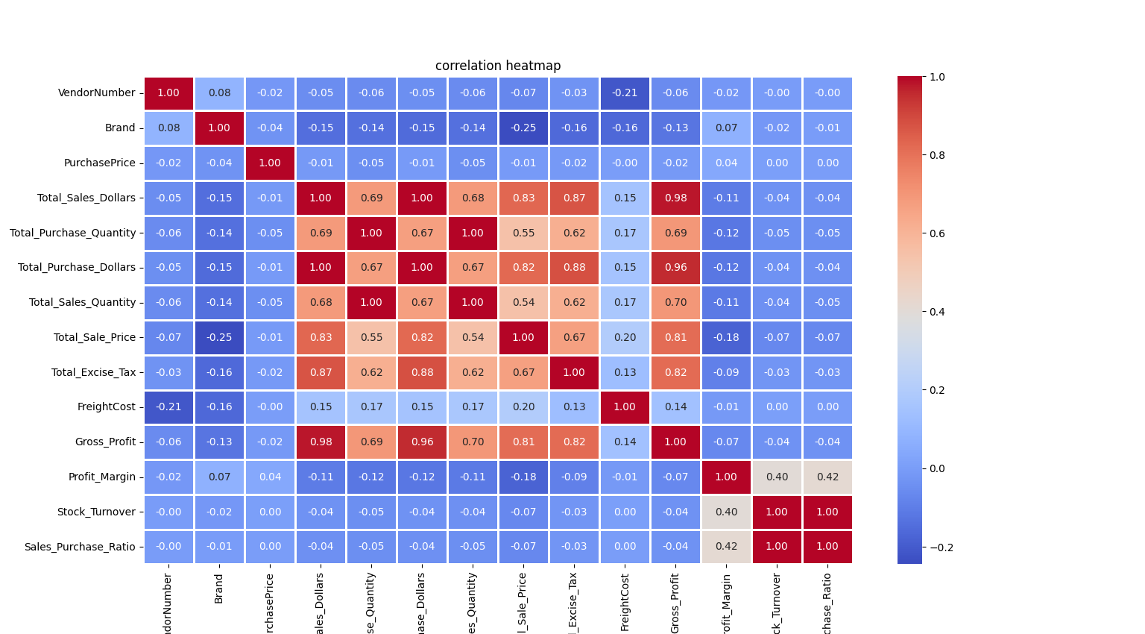

Purchase Price vs. Sales & Profit:
The correlation between purchase price and both total sales dollars and gross profit is very weak (-0.012 and -0.016). This suggests that changes in purchase cost have minimal direct influence on overall revenue generation or profitability.
Purchase Quantity vs. Sales Quantity:
A near-perfect positive correlation (0.999) between total purchase quantity and total sales quantity indicates highly efficient inventory movement, with stock being sold almost as quickly as it is acquired.
Profit Margin vs. Sales Price:
The negative correlation (-0.179) between profit margin and total sales price implies that increasing selling prices may compress margins, potentially due to discounting strategies, competitive pressure, or higher associated costs.

🔍 Research Questions & Key Findings
Q1: Brands for Promotional or Pricing Adjustments
Objective: Identify high-margin brands that are suffering from low sales volume.

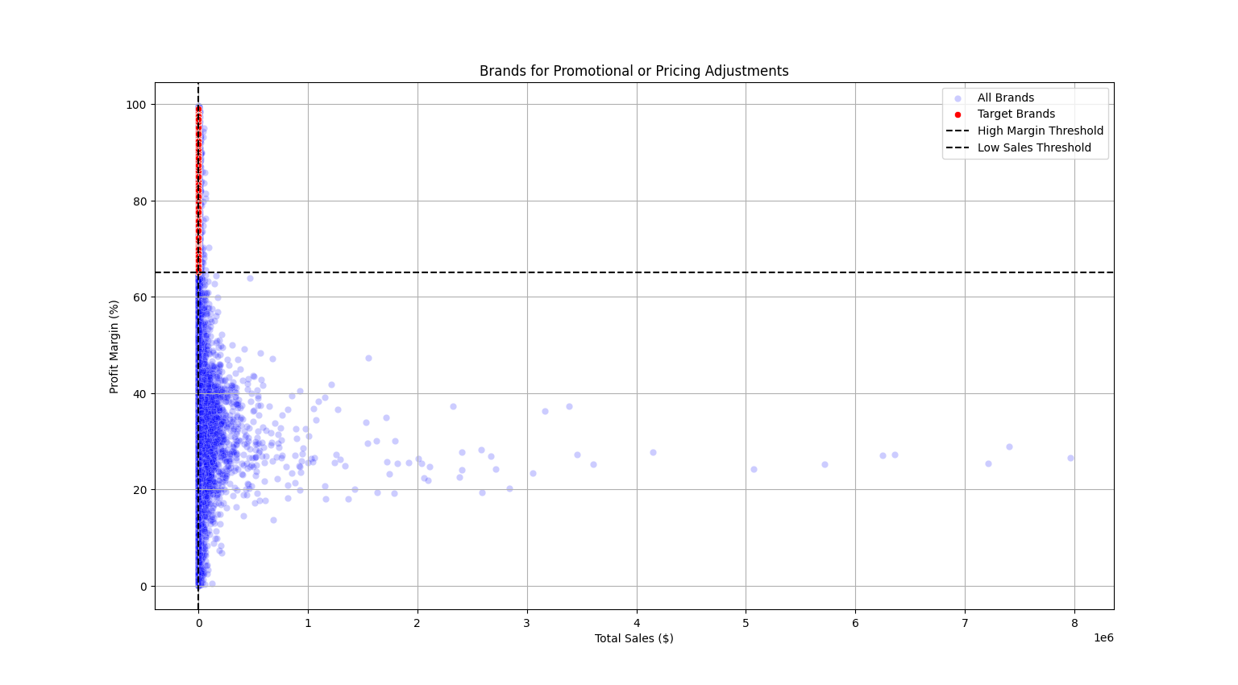
- Insight: 198 brands were identified as "Target Brands". These exhibit Profit Margins > 65% but Total Sales < $560.
- Action: These products would benefit from targeted marketing or small price reductions to increase volume without compromising overall profitability.
Q2: Top Vendors by Sales & Purchase Contribution
Objective: Determine vendor reliance and market leaders.

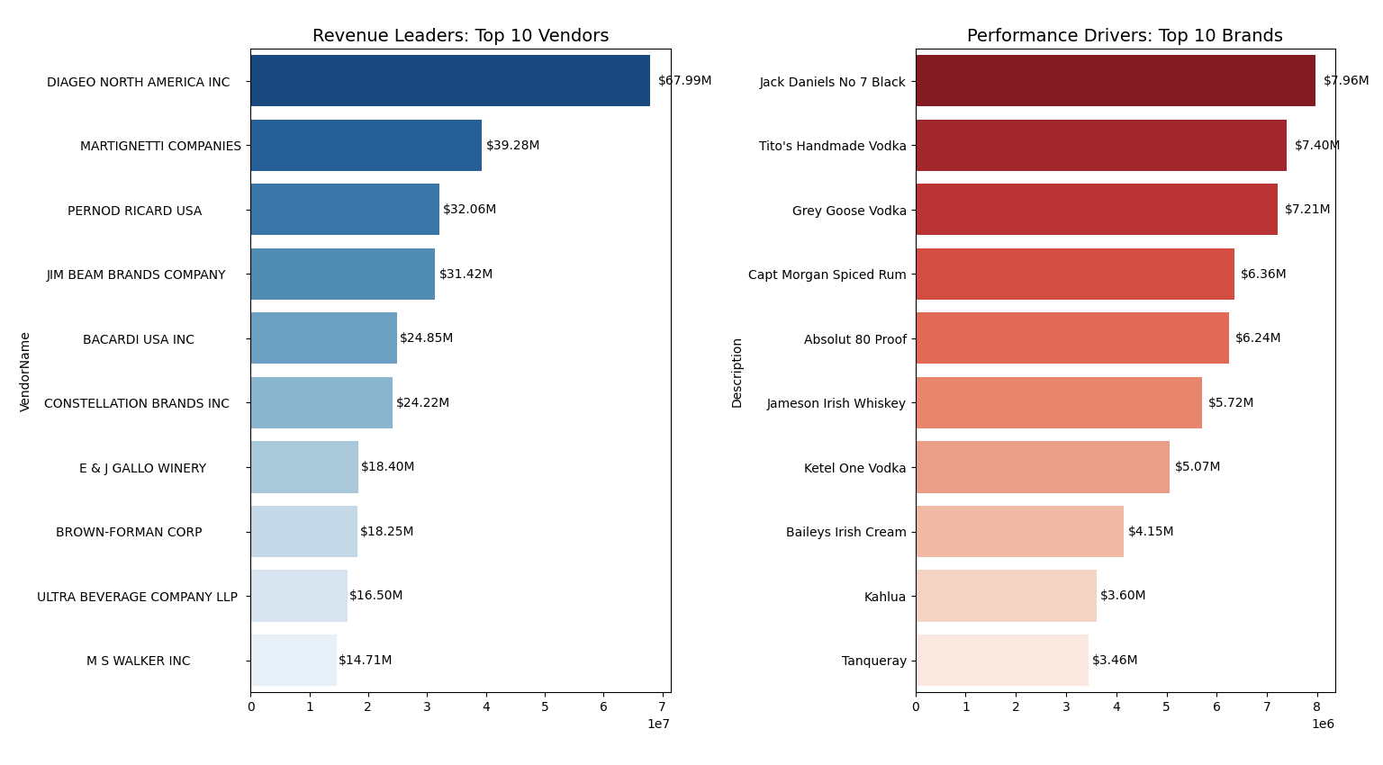
- Insight: The Top 10 vendors contribute 65.69% of total purchases.
- Leader: DIAGEO NORTH AMERICA INC is the primary contributor, representing 16.3% of the total.
- Risk: This indicates an over-reliance on a few key partners, suggesting a need for supply chain diversification.
Q3: Impact of Bulk Purchasing on Unit Price
Objective: Validate if economies of scale are being achieved.
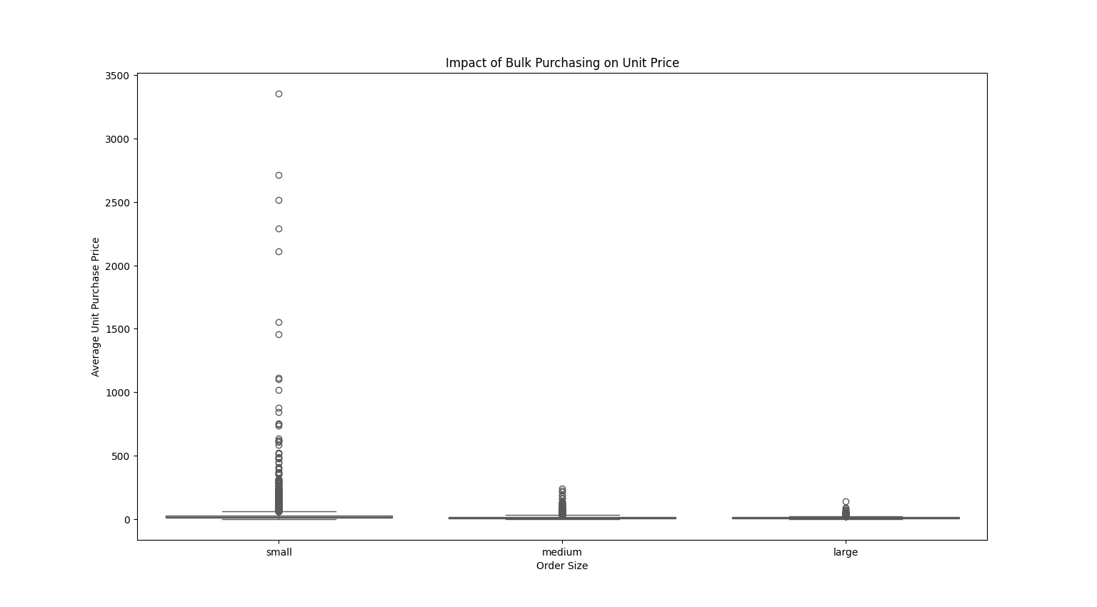

- Insight: There is a clear downward trend in unit price as order size increases.
- Finding: "Small" orders show significantly higher price volatility, with average prices near $39, whereas "Large" orders stabilize around $10.
Q4: Vendor Reliability (Sales-to-Purchase Ratio)
Objective: Identify the most efficient vendors in converting stock to revenue.
- Insight: Vendors like FLAVOR ESSENCE INC and DISARONNO INTERNATIONAL LLC show exceptionally high ratios, meaning they move inventory far more efficiently than the average vendor.
Q5: Inventory Turnover Efficiency
Objective: Identify slow-moving products and excess stock.
- Insight: A values greater than 1 indicates sales exceed current purchased quantities (using older stock), while values below 1 highlight vendors like ALISA CARR BEVERAGES where inventory is stagnant.
Q6: Freight Cost vs. Gross Profit Correlation
Objective: Determine if shipping costs are significantly eroding profits.
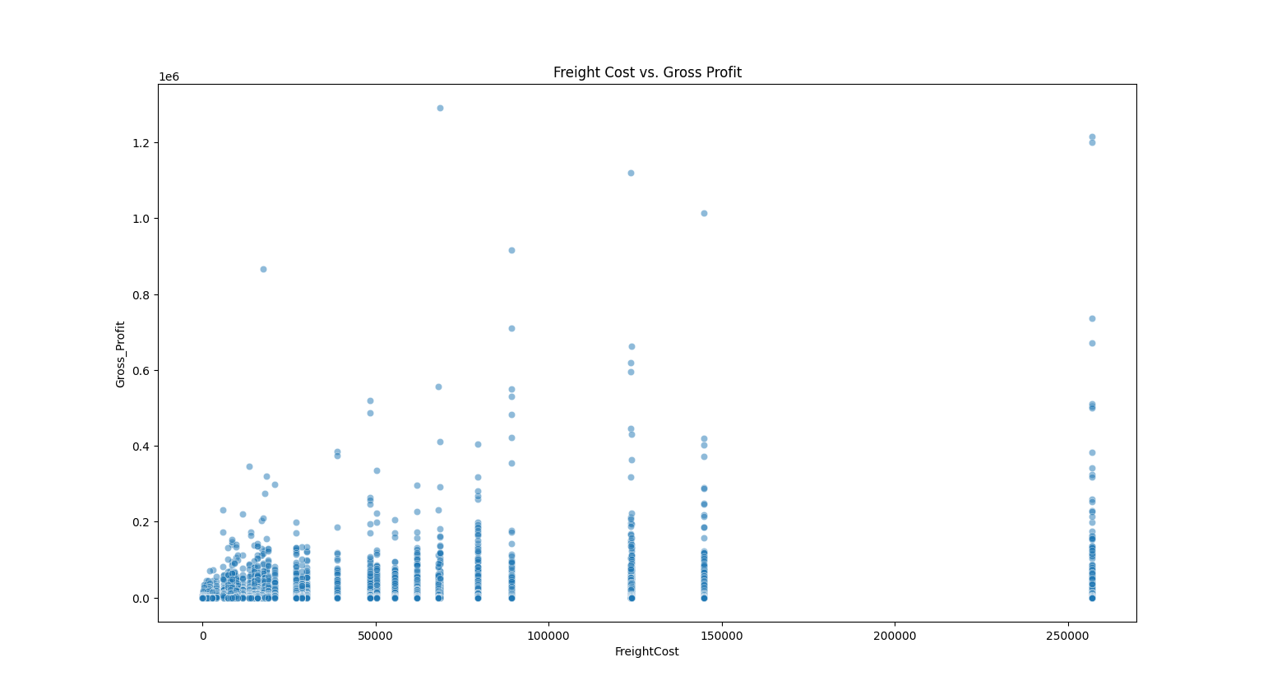
- Insight: The correlation is weak (0.14), indicating that current freight expenses are not a primary driver of profit loss.
- Observation: This suggests that shipping inefficiencies are localized rather than a systemic issue across all vendors.

💡 Final Recommendations
- Promotional Strategy: Launch a "High-Margin" campaign for the 198 identified target brands.
- Vendor Negotiation: Leverage the "Bulk Purchasing" data to renegotiate contracts with vendors currently only providing "Small" order price points.
- Risk Management: Diversify the supply chain to reduce the 65% reliance on the top 10 vendors.

